PUBLIC NOTICE
Public Hearing

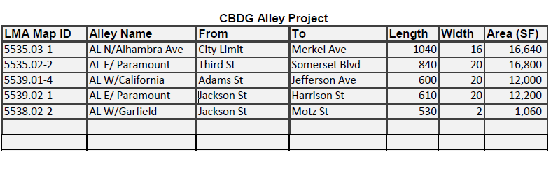

Dear Paramount Resident:

The City of Paramount intends to make improvements to existing alleys identified in the table above. This project will be made possible by using Community Development Block Grant (CDBG) monies. However, when the project went out to bid, the proposed bids were higher than what was originally budgeted for the project. Therefore, the City is proposing to make up the difference by using a portion of the unallocated CDBG monies from previous years, adjust the approved budget and amend the approved Annual Allocation Plan for FY 2023-24. To comply with the U.S. Department of Housing and Urban Development (HUD) regulations, the City has prepared a draft of the amended Annual Action Plan FY2023-2024. A copy of the draft amendment to the Annual Action Plan FY 2023-2024 has been made available to the public for review and comment for a minimum of thirty (30) day period starting February 28, 2024, to March 29, 2024. The document can be reviewed at the Planning Department, Paramount Community Center, and on the City’s website at www.paramountcity.com/community/cdbg.

You are invited to a Public Hearing to hear more about the proposed changes.

NOTICE IS HEREBY GIVEN that the City of Paramount will hold a Public Hearing to consider the following:

TIME/PLACE Tuesday, March 26, 2024, at 5 p.m.
OF HEARING: Paramount City Council Chamber, Paramount City Hall
16400 Colorado Avenue, Paramount CA 90723

Below is a summary of the details:

REQUEST: Notice of Public Review and Public Hearing to Amend the Annual Allocation Plan Fiscal Year 2023-24 to consider a request to increase the proposed budget for the Alley Improvements East Phase project.

LOCATION: Alley North of Alhambra Ave. from the City Limit to Merkel Ave., Alley East of Paramount Blvd. from Third St. to Somerset Blvd., Alley West of California Ave.
from Adams St. to Jefferson Ave., Alley East of Paramount Blvd. from Jackson St. to Harrison St., and Alley West of Garfield Ave. from Jackson St. to Motz. St.

ENVIRONMENTAL This project is a Categorically Excluded per 24 CFR 58.35(a), and subject to laws and authorities at §58.5:(1) Acquisition, repair, improvement, reconstruction, or
STATUS: rehabilitation of public facilities and improvements (other than buildings) when the facilities and improvements are in place and will be retained in the same use without change in size or capacity of more than 20 percent (e.g., replacement of water or sewer lines, reconstruction of curbs and sidewalks, repaving of streets).

ALL INTERESTED PERSONS are invited to participate in said Public Hearing to express their opinion about this matter. Provide comments orally, in writing, or via email to crequest@paramountcity.com. Emails must be received by 3:45 p.m. on Tuesday, March 26, 2024. Additional options for public participation may be provided at the time the agenda is posted.

ACCESSIBILITY TO MEETINGS AND DOCUMENTS It is the objective of the City to comply with Section 504 of the Rehabilitation Act of 1973, as amended, the Americans with Disabilities Act (ADA) of 1990 and the ADA Amendment Act of 2008, the Fair Housing Act, and the Architectural Barriers Act in all respects. If you require public documents in an accessible format, the City will make reasonable efforts to accommodate your request. If you require a disability-related accommodation to attend or participate in a hearing or meeting, including auxiliary aids or services, please contact the City Clerk’s Office at least 48 hours prior to the meeting at (562) 220-2027

LIMITED ENGLISH PROFICIENCY (LEP) An interpreter for Spanish speaking persons with Limited English Proficiency (LEP) is available at public hearing meetings. If you require program documents pertinent to the use of federal funds to be translated into a non-English language, the City will make reasonable efforts to accommodate your request.

EQUAL OPPORTUNITY The City does not and shall not discriminate on the basis of race, color, religion (creed), gender, gender expression, age, national origin (ancestry), disability, marital status, sexual orientation, or military status, in any of its activities or operations.

Any written correspondence regarding this matter should be delivered or mailed to the City Clerk, City Hall, 16400 Colorado Avenue, Paramount, California. For information, please contact the Sol Bejarano, Management Analyst at 562-220-2064 or sbejarano@paramountcity.com.

Heidi Luce
City Clerk

DATE OF PUBLICATION: Wednesday, February 28, 2024
Press Telegram

