AGENDA

Board of Appeals

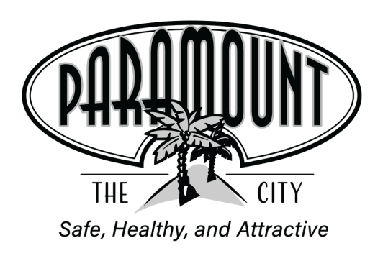
November 19, 2024

City Hall Council Chambers

6:00 p.m.

City Hall Council Chambers

16400 Colorado Avenue,  Paramount, CA 90723  (562) 220-2000  www.paramountcity.com
Public Comments: If you wish to make a statement, please complete a Speaker’s Card prior to the commencement of the Public Comments period of the meeting. Speaker’s Cards are located at the entrance. Give your completed card to a staff member and when your name is called, please go to the rostrum provided for the public. Persons are limited to a maximum of 3 minutes unless an extension of time is granted. No action may be taken on items not on the agenda except as provided by law.

Americans with Disabilities Act: In compliance with the Americans with Disabilities Act, if you need special assistance to participate in this meeting, please contact the Public Safety Department at (562) 220-2002 at least 48 hours prior to the meeting to enable the City to make reasonable arrangements to ensure accessibility to this meeting.

Note: Agenda items are on file in the Public Safety office and are available for public inspection during normal business hours. Materials related to an item on this Agenda submitted after distribution of the agenda packet are also available for public inspection during normal business hours in the Public Safety Department. The Public Safety Department is located at the Paramount Sheriff’s Station, 15001 Paramount Boulevard, Paramount.

Notes
 | CALL TO ORDER: | Chair Gerardo Ruiz
 | ROLL CALL OF MEMBERS: | Board Member Robert Cruz  Board Member Dora Sanchez  Board Member Steve Yanez  Vice Chair Marcelina Bridges  Chair Gerardo Ruiz
 | PUBLIC COMMENTS
 | NEW BUSINESS
 | - APPROVAL OF MINUTES | October 15, 2024
2. REPORT December Board of Appeals Meeting

COMMENTS & ANNOUNCEMENTS
- BOARD MEMBERS
- STAFF
 | ADJOURNMENT
 | To a regular meeting on Tuesday, December 17, 2024 at 6:00 p.m.

